**Questions and Answers for Developer Success Engineer Position with Auth0**

1. What has been your proudest achievement? It can be a personal project or something you’ve worked on professionally. Just a short paragraph is fine.

**Answer:** In 2003, without knowing anything about how difficult it would be, I agreed with my employer to make a software tool in 2 days that would allow a user to drag and drop items from a toolbox and connect them with lines and redraw those connections, etc.  
  
It took me a week or more and I suffered through it but also enjoyed it. I did it all using Win32 API with VB 6, mostly using Win32 raster operations and bitmap API for the drawing. It didn't have a lot of bells and whistles but it made me really proud.   
  
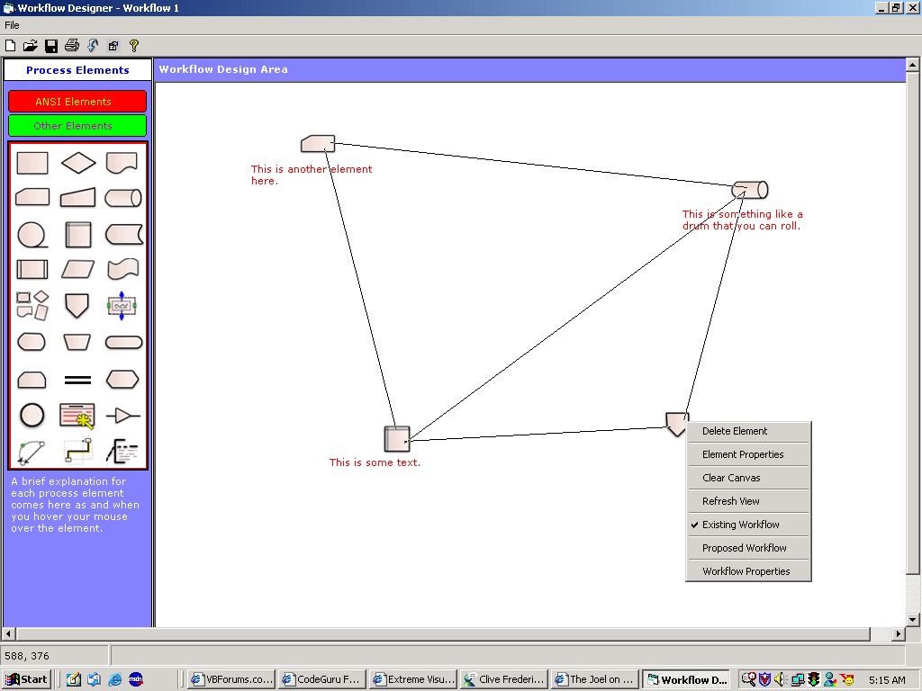

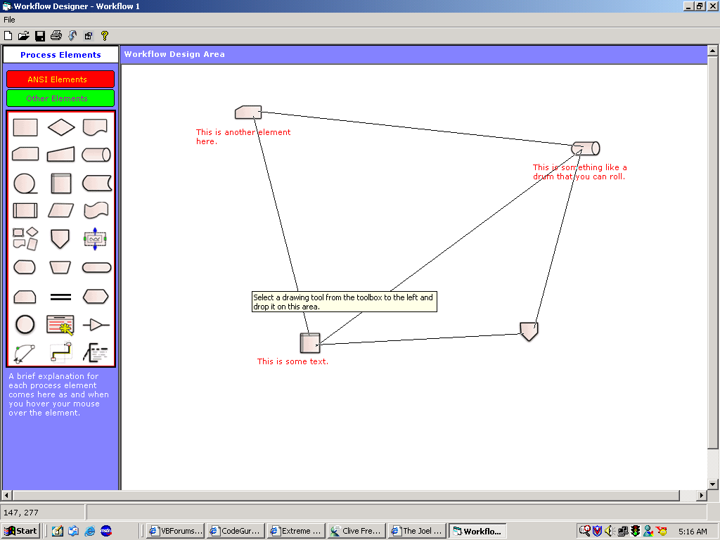

1. Share an experience where you provided great assistance to a customer.

**Answer:**  I was responsible for implementing a client server application in Visual Basic 6 back in 2003. We had a team of 7 junior (and I am being polite here) programmers and I coded the entire application *inspite* of their being on the team. I was the only *de facto* implementer of the application and the client asked the Project Manager, who was also a non-programmer, to just talk directly to me. I took most issues and solved them myself providing a quick turnaround every time. The client was very happy with me. This forced my employer to triple my salary and promote me many levels up.

1. What did you find attractive about the Developer Success Engineer position?  
     
   **Answer:** It is a research based position and I am intellectually included. I’ve been teaching along with consulting for a long time and I like learning things, doing little programs, writing articles, simplifying things for people and teaching it to them.
2. Auth0 breathes a hacking culture. Hack something (whatever you want) using webtask.io. Here is an example of a cool hack: <https://auth0.com/blog/2015/07/28/if-this-then-node-dot-js-extending-ifttt-with-webtask-dot-io/>

**Answer:** I sometimes make fixed deposits with my bank. The bank allows me to specify the number of days I'd like to maintain the deposit for. It doesn't show me the maturity date of the deposit, though, until 2 hours after having made the deposit. This makes me want to just add up the number of days of the deposit to today's date to quickly get to know the maturity date.

Sometimes, I fire up Visual Studio to write this little function, and at other times, I fire up LINQPad. If I were a JavaScript developer, I'd fire up the Node REPL or the ScratchPad in Developer Tools that most modern browsers offer.

Here is a quick function that I made a Webtask out of that will help me add the number of days to a base date. The usage is:

url?b={yyyy-mm-dd}&n={numberOfDays}

where b is the base date to which the number of days is to be added:

<https://webtask.it.auth0.com/api/run/wt-sathyaish-gmail_com-0/addDays?webtask_no_cache=1>